**Practical No. 5**

**Q1. Installation.**

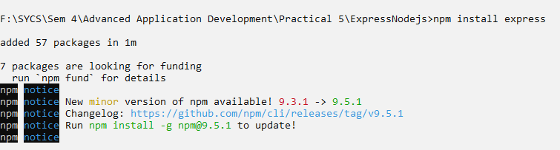

**Q2. Creating ‘Hello World’ app using express.**

**Code:**

var express=require('express');

var app=express();

app.get('/',function(req,res){

res.send("Welcome to express framework");

});

app.listen(3030);

console.log("Express server is started and it is waiting for client connections on port no. 3030");

**Output:**



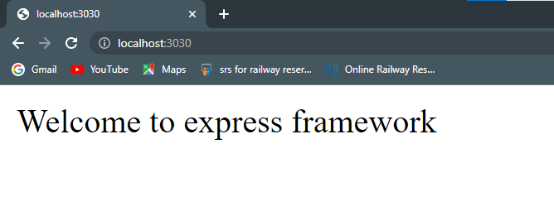

**Q3. Working with express router.**

**Code:**

var express=require('express');

var app=express();

app.get('/home',function(req,res){

res.send("Welcome from route home...");

})

app.get('/login',function(req,res){

res.send("Welcome from route login...");

})

app.listen(3030);

console.log("Express server is started...");

**Output:**



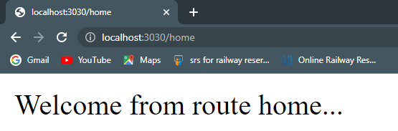

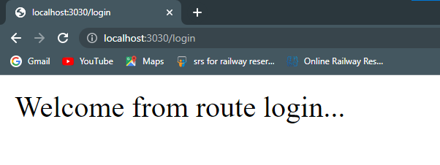

**Q4. Passing request data in route using express.**

**Code:**

var express=require('express');

var app=express();

app.get('/home/:name/:id',function(req,res){

res.send("User name is "+req.params.name+" and id is "+req.params.id);

})

app.listen(3030);

console.log("Express server is started...");

**Output:**



